JWT + Spring Security

1. Why Security Matters in Backend?
Security in backend systems is primarily about protecting user identity and data.
The biggest risk is storing sensitive data like passwords in plain text.
If a database is compromised, attackers instantly gain access to all user accounts.
Instead of storing passwords directly, we use hashing:
- Hashing is one-way (cannot be reversed)
- Encryption is two-way (can be decrypted)
Therefore:
- Passwords → hashed
- Data transmission → encrypted (HTTPS)

2. Hashing vs Encryption
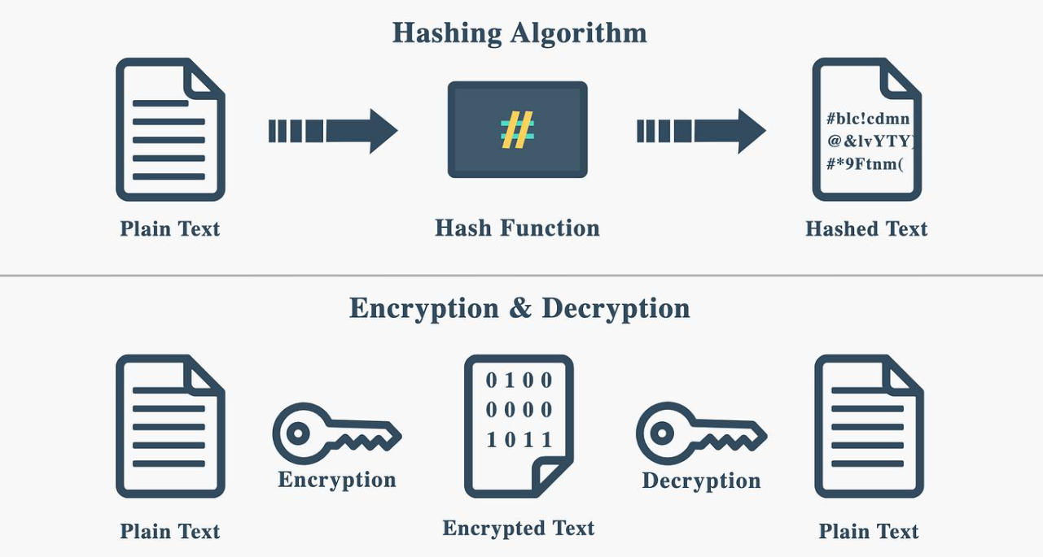
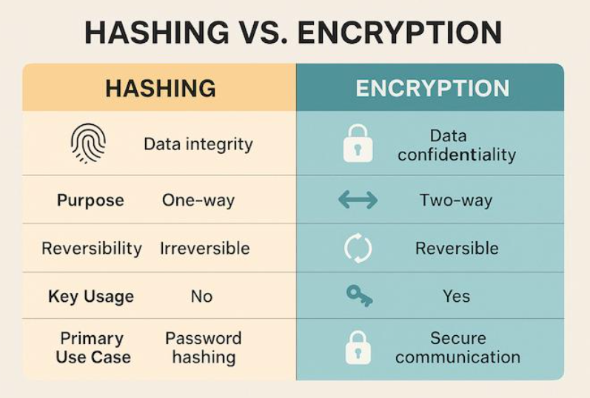
BCrypt Hashing Irreversible
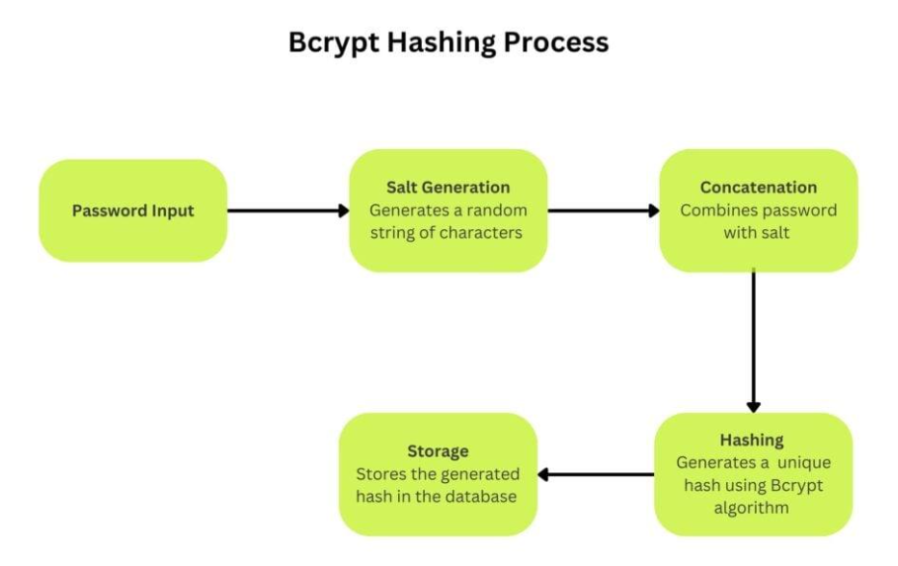

3. What is Rehashing?
When a user logs in:
- You compare raw password with stored hash
- Internally, BCrypt rehashes input and compares
This protects against:
- Rainbow table attacks
- Precomputed hash attacks

4. Code & Explanation
- encode() → hashes password
- Stored value is never reversible
- Takes raw password
- Hashes again internally
- Compares safely
Never:
- Store plain passwords
- Log passwords
- Send passwords in responses

Spring Security Architecture Overview
Spring Security provides a centralized mechanism to:
- Authenticate users
- Authorize requests
- Intercept every HTTP request
Without it, you’d manually secure each API → error-prone and unsafe.
2. How It Works (Request Flow)
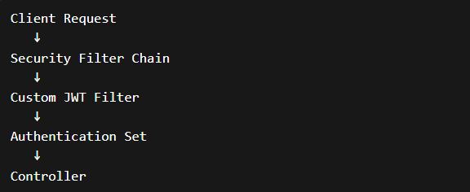
3. SecurityFilterChain (Config)
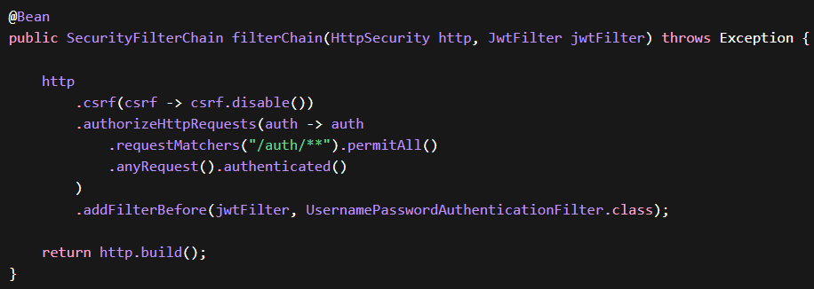csrf.disable() → allows Postman testing
- /auth/** → open APIs
- anyRequest().authenticated() → secure everything else
- addFilterBefore() → inject your JWT logic
🔐 Pro Tip
Never disable CSRF in production for browser apps
(only safe for stateless APIs)
JWT Flow Explained Simply
JWT allows stateless authentication:
- No session stored in server
- Token carries identity
Scalable and fast
2. JWT Structure
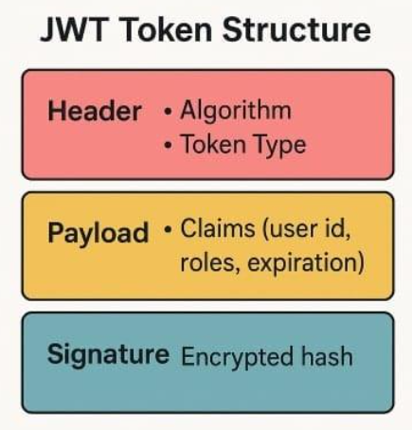
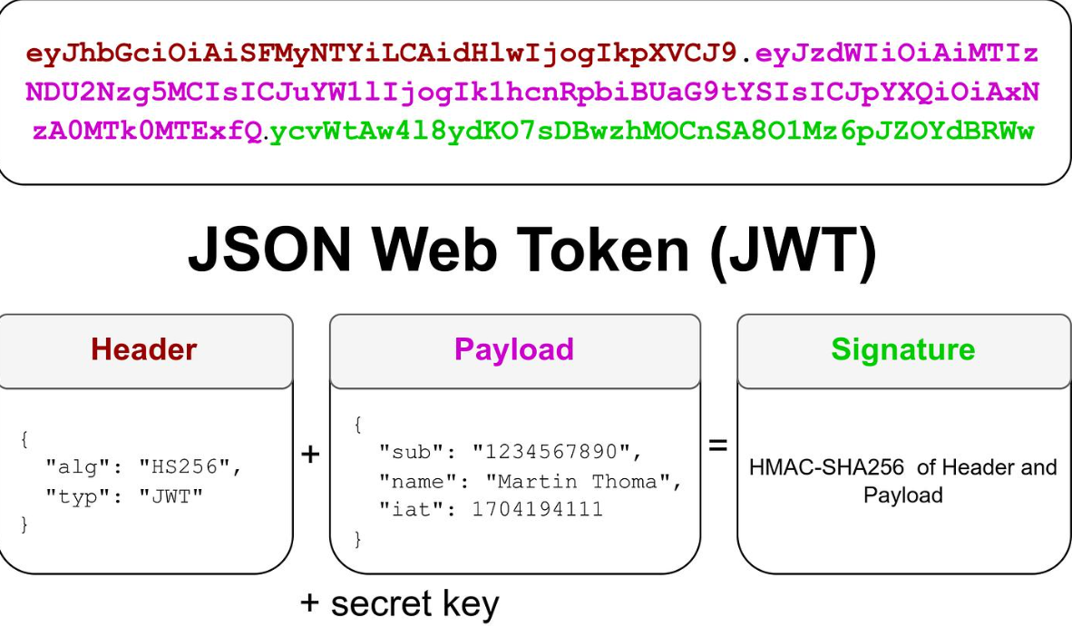
3. JWT Lifecycle
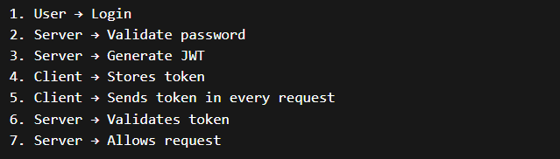
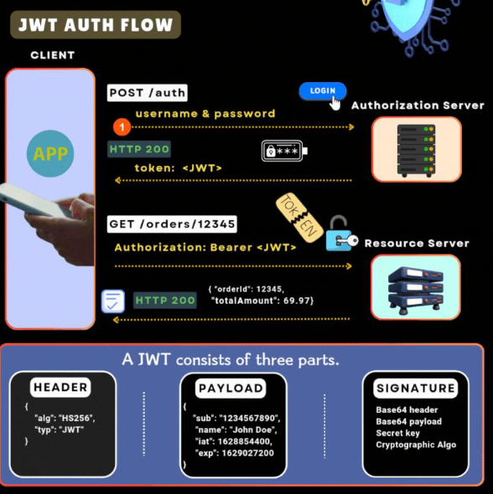

4. Code & Explanation
4.1 Token Generation
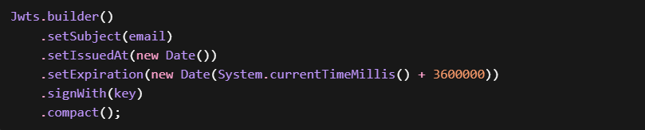
- subject → identity
- expiration → token expiry
- signWith() → prevents tampering
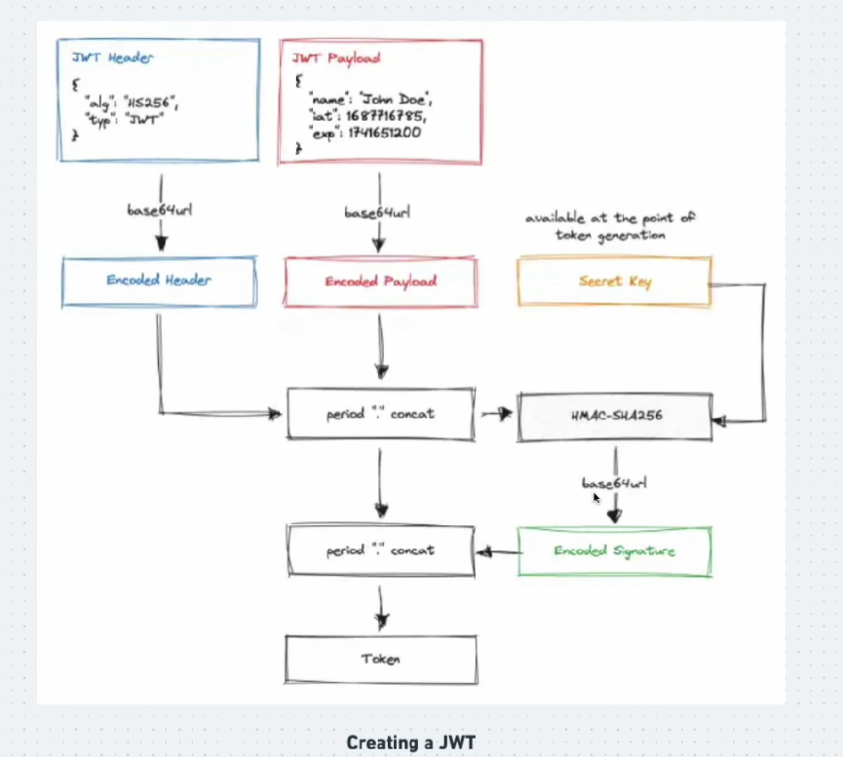

4.2 Token Validation
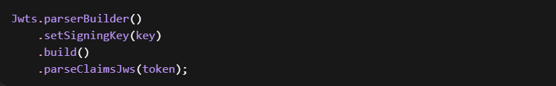
- Validates signature
- Checks expiry
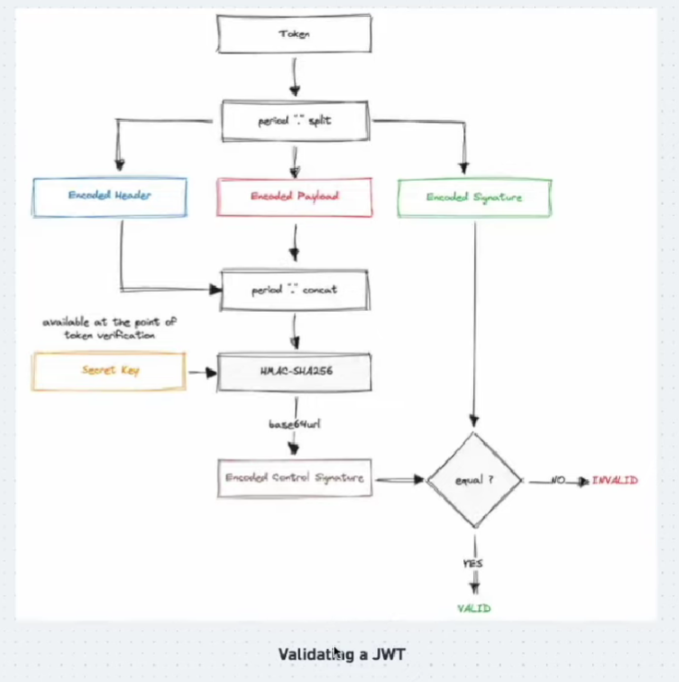
🔐 Pro Tip
- Never expose secret key
- Keep expiry short (15–60 mins)
- Use refresh tokens in real systems
JWT Authentication flow
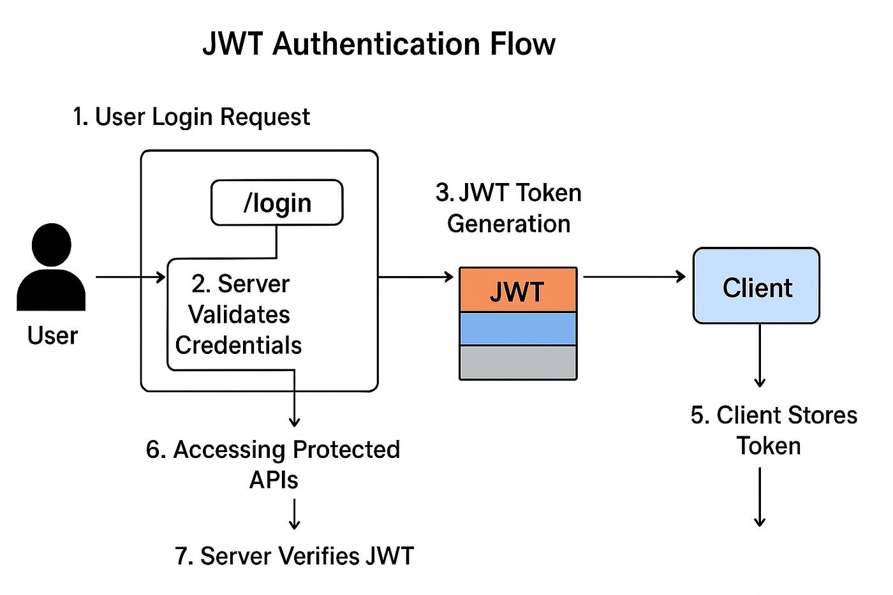
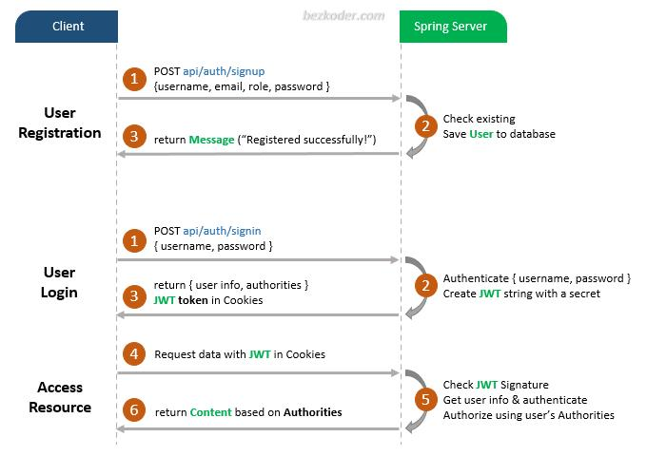

JWT Authentication Flow
- User sends login request
→ email + password
- Backend validates credentials
→ fetch user + passwordEncoder.matches()
- If valid → generate JWT
→ includes claims (user, role, expiry)
- JWT sent to client
→ in response body
- Client stores JWT
→ localStorage / memory
- Client sends API request
→ adds header:
- Authorization: Bearer <token>
- Spring Security intercepts request
→ via JWT filter
- Extract token from header
→ remove "Bearer "
- Validate token
  - signature check
  - expiry check
  - tampering check
- If valid → extract user details
→ username + roles (from claims)
- Set authentication in context
→ SecurityContextHolder
- Request proceeds to controller
→ access granted (if authorized)
If Token Invalid
- ❌ Missing / wrong → 401 Unauthorized
- ❌ Role mismatch → 403 Forbidden
Login → Get Token → Send Token → Validate → Allow/Block Request
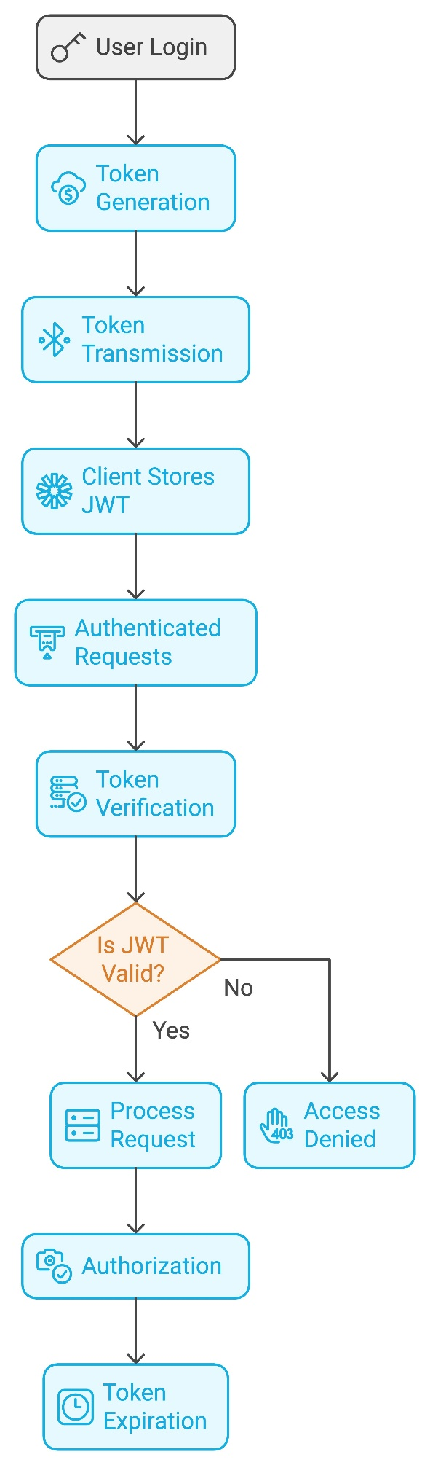
JWT Flow → Project Mapping
1. User logs in
📍Controller Layer Entry point of flow
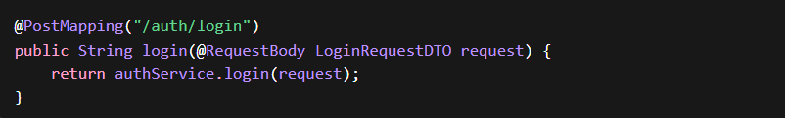
2. Backend authenticates user
📍 AuthService
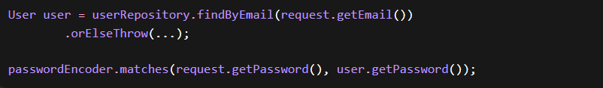
3. JWT is generated
📍 JwtService (NEW CLASS) Called after password is valid
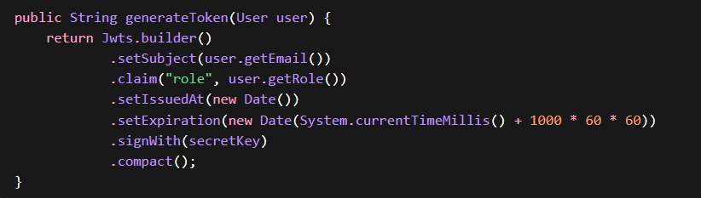
4. Token sent to client
📍 AuthService
5. Client stores JWT
📍 Frontend / Postman
- Postman → manually copy token
- Angular → localStorage

6. Client sends request with token
Every secured API request

7. Request intercepted
📍 JwtFilter (NEW CLASS)
Runs before controller

8. Extract + validate token
📍 JwtFilter + JwtService
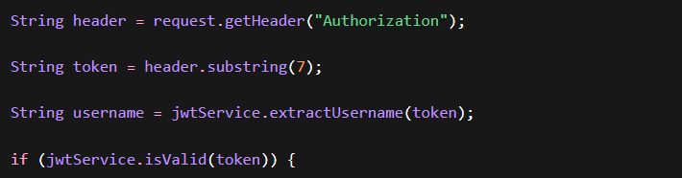 Core validation logic
9. Set authentication
📍 JwtFilter
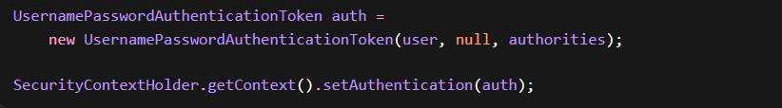 Marks request as authenticated
10. Request proceeds / blocked
📍 Spring Security + Controller
- ✅ Valid → Controller runs
- ❌ Invalid → 401
- ❌ Role mismatch → 403
🔹 SecurityConfig
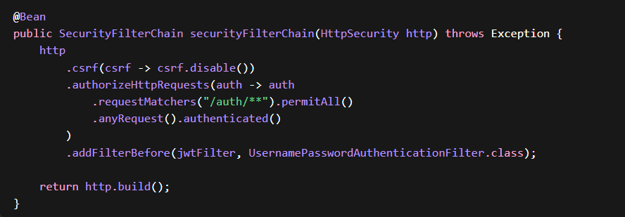 👉 Connects everything

Full Mapping in One View
Step | What Happens | Class
1 | Login request | Controller
2 | Validate password | AuthService
3 | Generate JWT | JwtService
4 | Return token | AuthService
5 | Store token | Client
6 | Send token | Client
7 | Intercept request | JwtFilter
8 | Validate token | JwtService
9 | Set authentication | JwtFilter
10 | Allow / Deny | SecurityConfig

Securing REST APIs
1. The Why
Once authenticated, backend must:
- Identify user
- Allow or deny access
This is done using Security Context

2. How It Works (Your Implementation)
Inside JwtFilter:
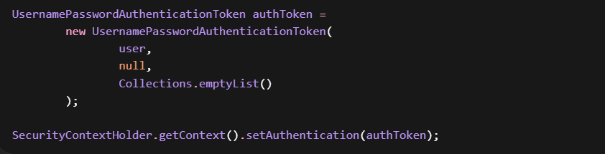
- Creates authentication object
- Stores it in Spring Security context
Now Spring knows “This request is authenticated”

3. Bearer Token Flow
Client sends:
Filter:
- Extract token
- Validate
- Extract email
- Load user
- Set authentication
4. Flow Important
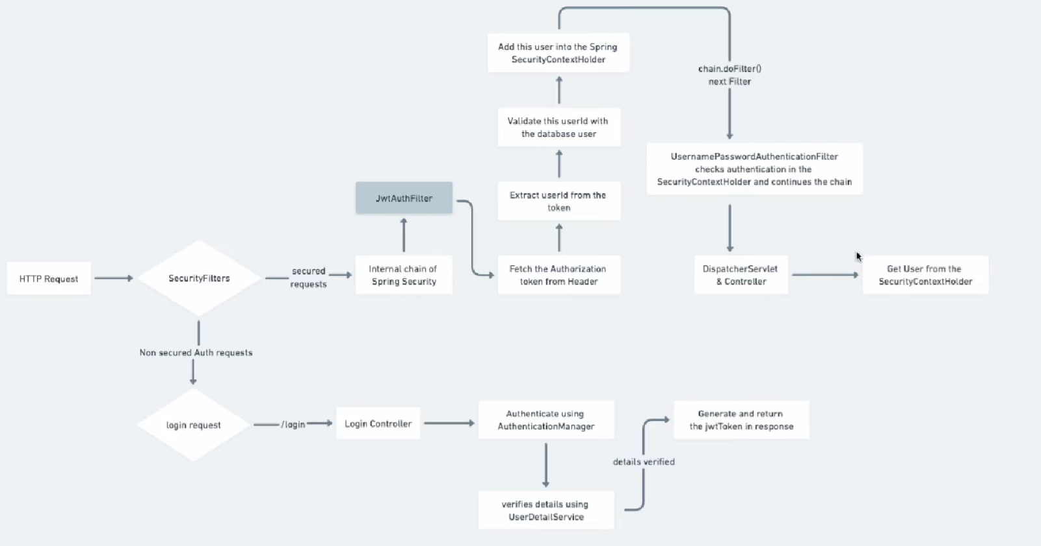
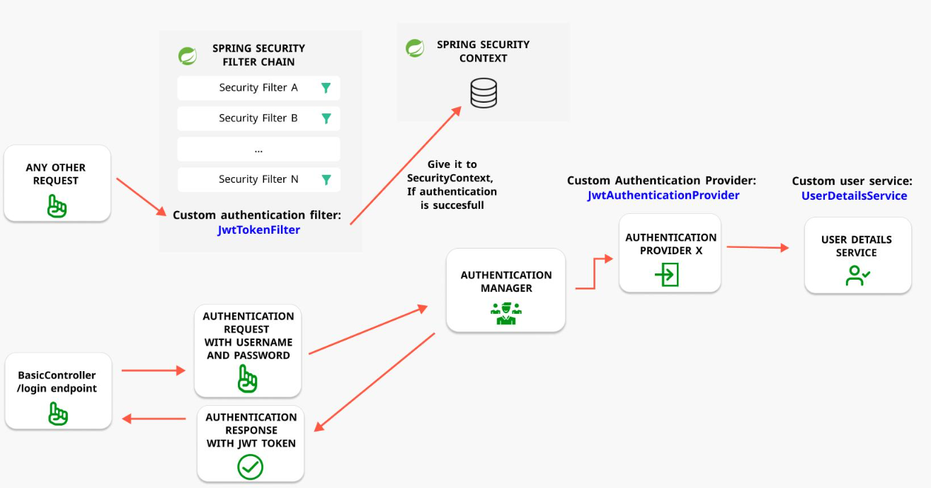
- Controller → handles HTTP
- Service → handles logic
- Repository → handles DB
- Security → handles authentication
- JWT → replaces session

Annotation Cheat Sheet (Till Now – Backend + Security)
Annotation | Layer | Used In | Purpose | Key Note
@SpringBootApplication | Core | Main class | Bootstraps application | Enables component scan + auto-config
@Configuration | Core | Config classes | Defines configuration class | Used for beans
@Bean | Core | Config classes | Registers object in Spring context | Example: PasswordEncoder
@Component | Core | JwtUtil, JwtFilter | Generic Spring bean | Used when no specific stereotype
@Service | Service | AuthService, UserService | Business logic layer | Clean separation
@Repository | Repository | JPA repos | Data access layer | Enables exception translation

🌐 Web Layer
Annotation | Layer | Used In | Purpose | Key Note
@RestController | Controller | Controllers | REST API controller | Returns JSON by default
@RequestMapping | Controller | Controller class | Base URL mapping | Example: /auth
@PostMapping | Controller | APIs | Handles POST requests | Used for login/register
@GetMapping | Controller | APIs | Handles GET requests | Used for testing
@RequestBody | Controller | API params | Maps JSON → Java object | Required for POST
@Valid | Validation | DTO input | Triggers validation | Works with constraints

🧾 Validation
Annotation | Layer | Used In | Purpose | Key Note
@NotBlank | DTO | Request DTO | Field cannot be empty | For strings
@Email | DTO | Request DTO | Valid email format | Basic validation

🗄️ JPA / Entity
Annotation | Layer | Used In | Purpose | Key Note
@Entity | Entity | All entities | Maps class → table | Mandatory
@Table | Entity | Entities | Custom table name | Optional
@Id | Entity | Entity fields | Primary key | Required
@GeneratedValue | Entity | ID field | Auto-generate ID | Usually IDENTITY
@Column | Entity | Fields | Column constraints | Unique, nullable
@ManyToOne | Entity | Relationships | Many → One mapping | Example: User → Role
@JoinColumn | Entity | Relationships | Foreign key column | Defines FK
@MappedSuperclass | Entity | BaseEntity | Common fields reuse | Not a table
@PrePersist | Entity | BaseEntity | Before insert | Set createdAt
@PreUpdate | Entity | BaseEntity | Before update | Set updatedAt

🔐 Spring Security (Core to JWT Flow)
Annotation / Class | Layer | Used In | Purpose | Key Note
SecurityFilterChain | Config | SecurityConfig | Defines security rules | Replaces WebSecurityConfigurer
OncePerRequestFilter | Security | JwtFilter | Runs once per request | JWT validation logic
UsernamePasswordAuthenticationToken | Security | JwtFilter | Represents authenticated user | Passed to context
SecurityContextHolder | Security | JwtFilter | Stores authentication globally | Used by Spring Security
PasswordEncoder | Security | Service/Config | Password hashing interface | BCrypt implementation
BCryptPasswordEncoder | Security | Config | Hashing algorithm | Secure + salted

JWT (Library Usage – Not Annotations)
Class / Method | Purpose | Key Note
Jwts.builder() | Create token | Used in login
setSubject() | Store user identity | Usually email
setExpiration() | Token expiry | Security control
signWith() | Sign token | Prevent tampering
parseClaimsJws() | Validate token | Checks signature + expiry

⚙️ Lombok (Very Important)
Annotation | Layer | Used In | Purpose | Key Note
@Data | DTO/Entity | DTOs | Getter + Setter + toString | Avoid boilerplate
@RequiredArgsConstructor | Service/Controller | Classes with final fields | Constructor injection | Preferred over @Autowired

Backend Flows in 🔗 Library Management System
- Application Startup Flow
- Registration API Flow
- Login API Flow (JWT generation)
- Protected API Flow (JWT validation)
- End-to-End Request Lifecycle (with Security)
1. APPLICATION STARTUP FLOW (What happens when app starts)
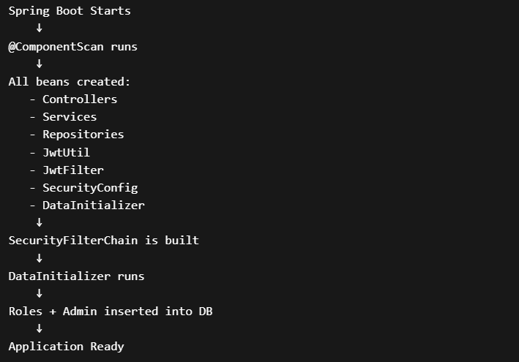
What is important here
- @SpringBootApplication → scans everything
- @Configuration → registers beans
- @Bean → creates PasswordEncoder + SecurityFilterChain
- @Component → registers JwtFilter, JwtUtil
- CommandLineRunner → runs AFTER app starts
👉 So before any API call System is fully wired and ready

2. REGISTRATION API FLOW
API:
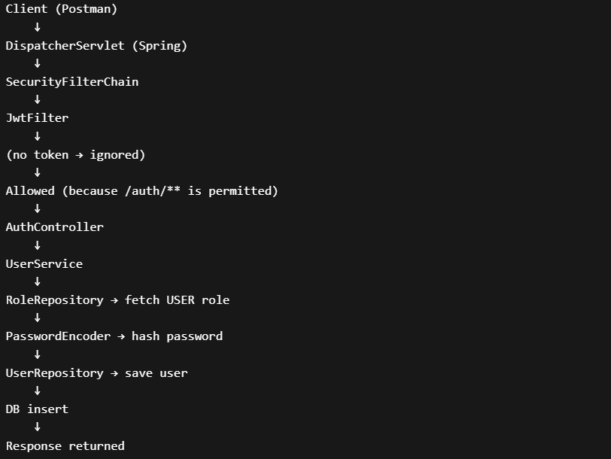
Layer | Role
Controller | Accepts request
Service | Business logic
Repository | DB interaction
Config | PasswordEncoder injected
Security | Allows request

- No JWT involved here
- Security allows /auth/**
- Password gets hashed before DB
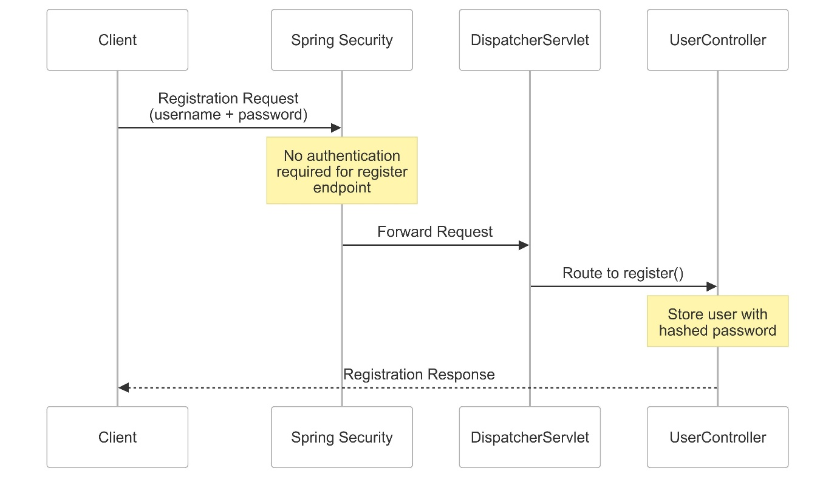

3. LOGIN API FLOW (JWT CREATION)
API
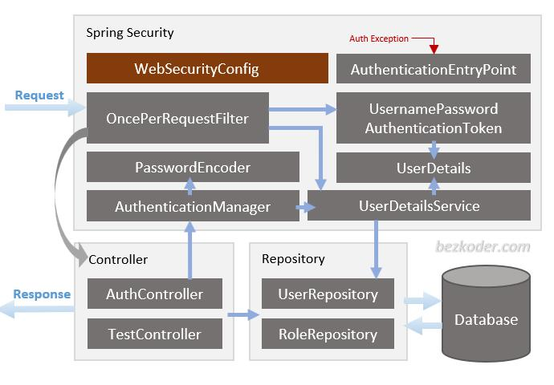
Flow
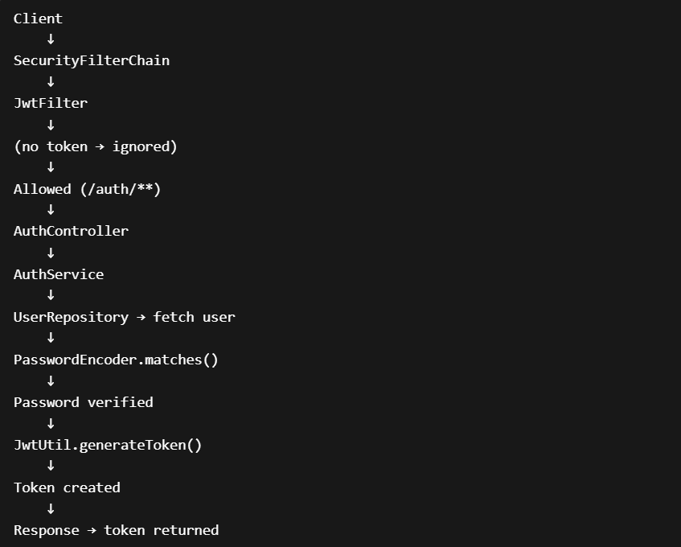
- Password is NOT decrypted
- Raw password is rehashed and compared
- JWT is generated with:
  - email
  - expiry
  - signature

👉 Login does NOT create session
👉 It creates a token

4. PROTECTED API FLOW (JWT VALIDATION)
Flow
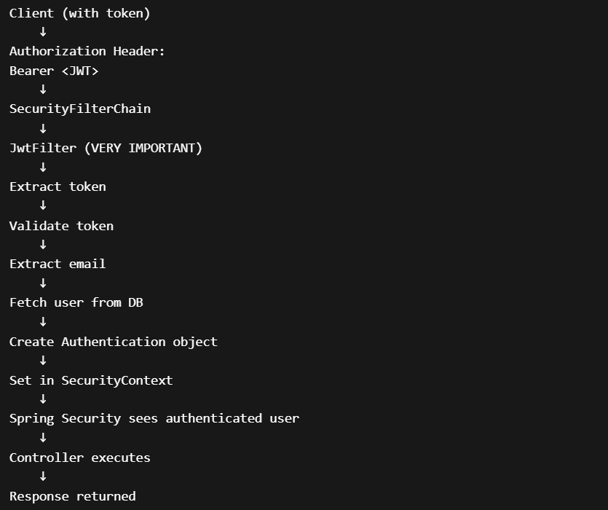
Before JWT | After JWT
Anyone can call | Only valid token
No identity | User identity known
No protection | Protected APIs

SecurityContextHolder = “Who is the user?”
Once set: 👉 Request is considered authenticated

🔁 5. FULL REQUEST LIFECYCLE (VERY IMPORTANT)
Generic flow for ANY request
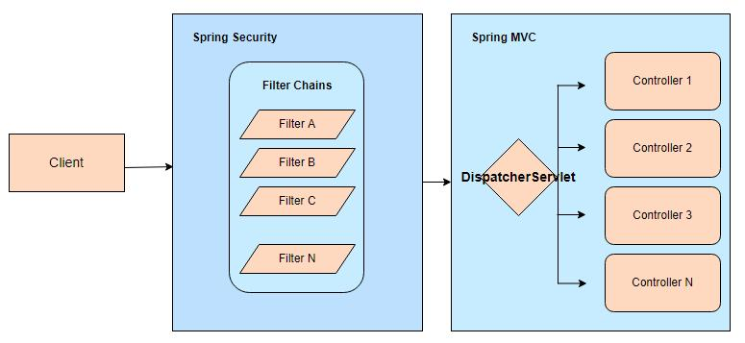
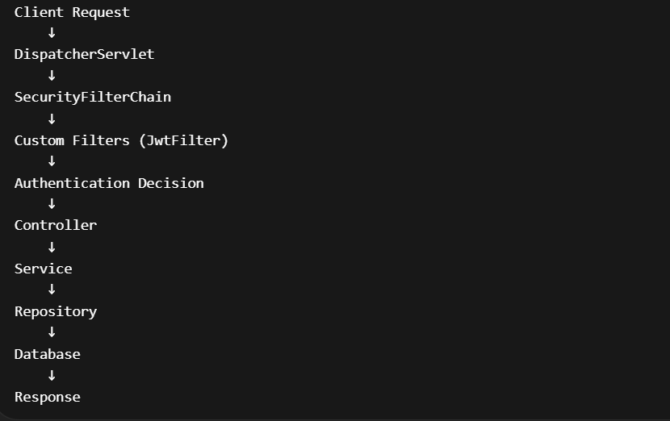
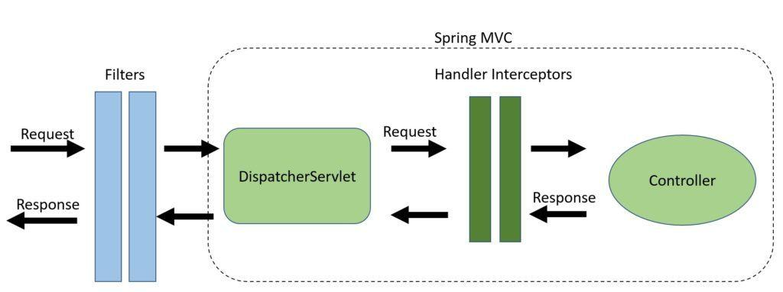
WHERE EACH FILE IS USED
File | When It Runs
SecurityConfig | App startup
JwtFilter | Every request
JwtUtil | Login + token validation
DataInitializer | App startup
Controller | When API is called
Service | Inside controller
Repository | Inside service
Entity | When DB interaction happens

FINAL MENTAL MODEL
Think like this:
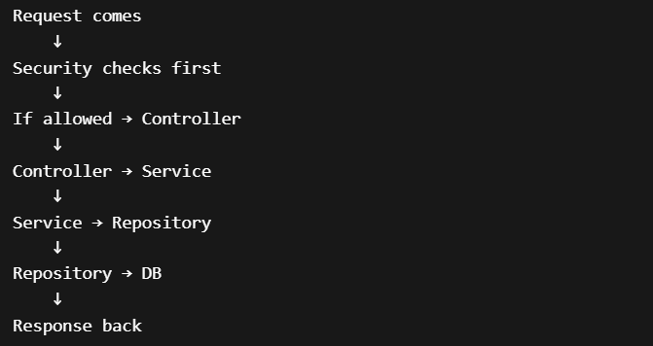

🔍 CASES SUMMARY
Case 1 – Register
- No token needed
- Password hashed
- User saved
Case 2 – Login
- Password verified
- JWT generated
Case 3 – Protected API
- Token required
- Token validated
- User authenticated
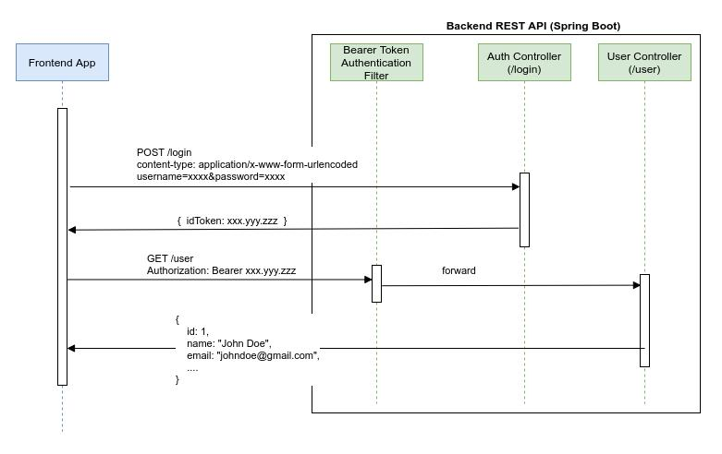

Spring Security Filter Chain
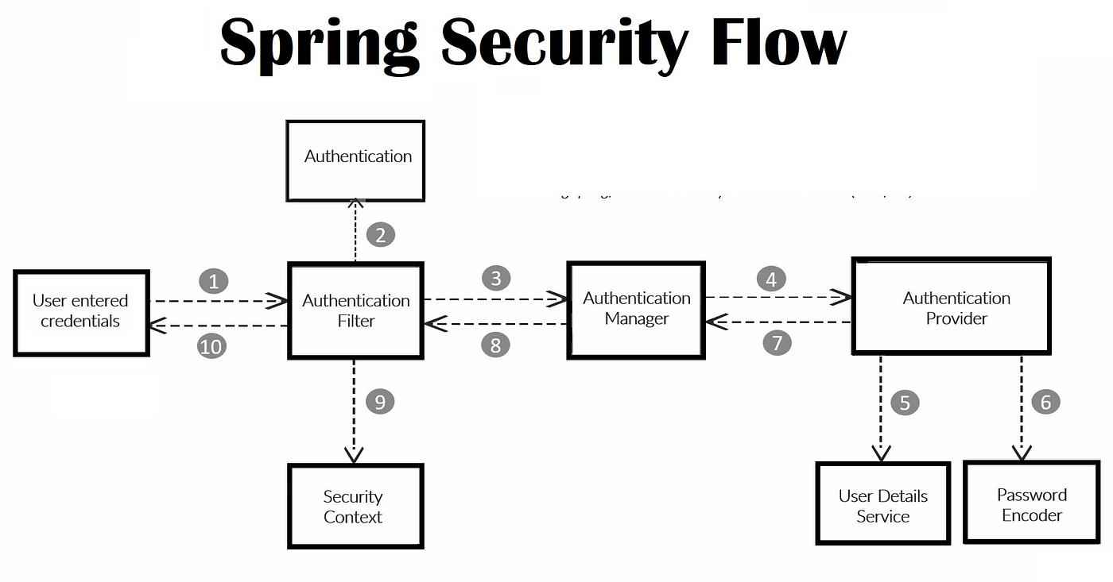

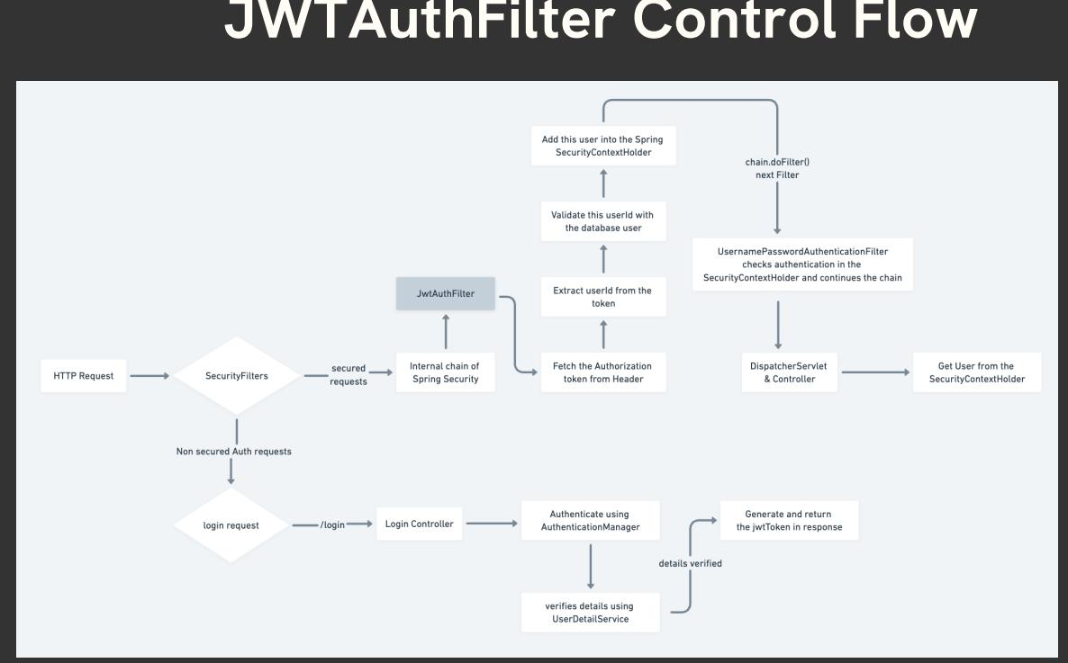

FINAL UNDERSTANDING CHECK
If you understand this, you should be able to answer:
- Who calls JwtFilter? → Spring Security
- When? → Every request
- Who creates beans? → Spring container
- Who routes API? → DispatcherServlet
- Who talks to DB? → Repository
- Who holds logged-in user? → SecurityContext

LinkedIn : https://www.linkedin.com/in/kolisetty-surya-mahesh-k789/
Library Management System : https://github.com/SuryaMahesh789/library-management-system-springboot-angular

